- Log in to Dayforce using your employee number and password. Ensure the Company says americasthrift. (If you have forgotten either your Username or Password, click on Can’t access your account? Below the sign in window and follow the steps for recovery.)

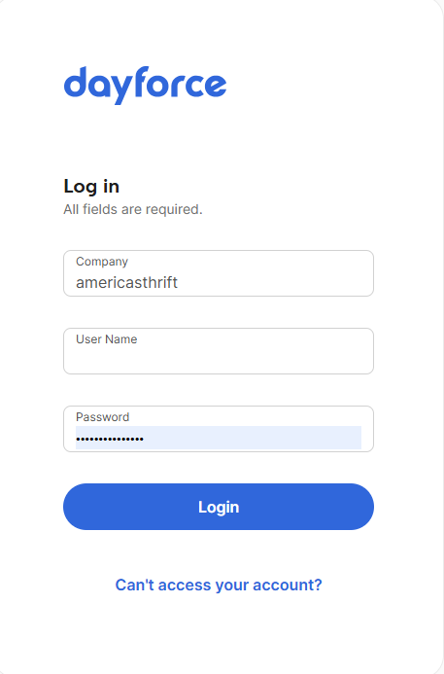
- Click on the hamburger icon and select Earnings.
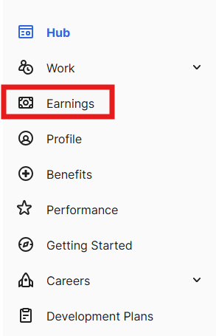
The window will display, and you will see two or three options at the top. Select Year End Forms. Choos the year and form type W2 for the desired year. A window will display where you will be able to print your W2.
